**LAB AUTOMATION**

**Synopsis**

**Submitted to the**



**For the partial fulfilment of the requirement for the e-project of semester 2 Diploma in Software Engineering**

**ADSE I (2023-2023)**

**SUBMITTED BY**

Student1376511 Umar Farooq Khan

Student1385765 Junaid Ahmed

Student1379364 Ahsan Rahim

Student1372330 Nouman

**SUPERVISOR NAME**

Sir Muhammad Aqueel

**Project Title**

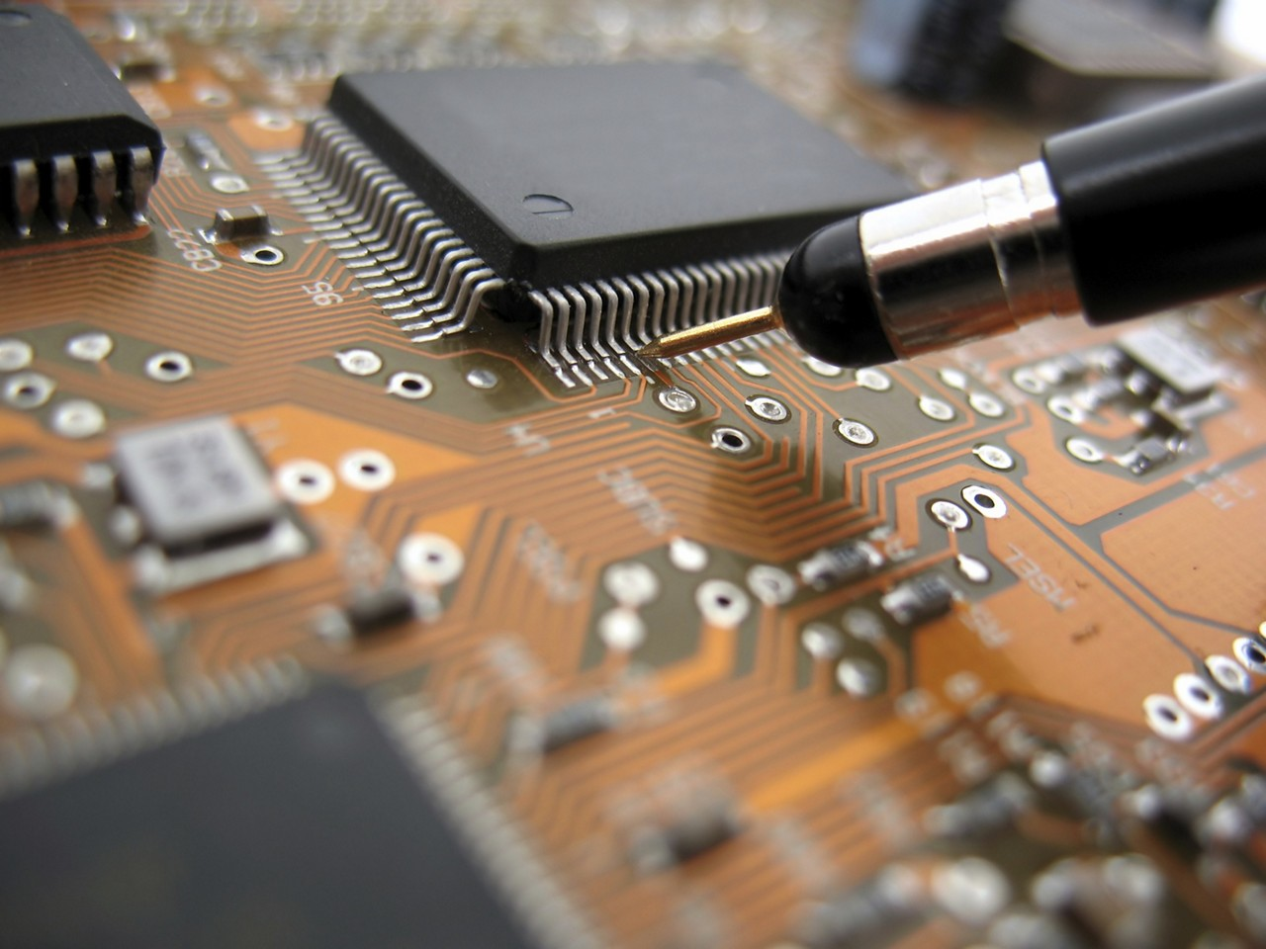**LAB AUTOMATION**

**Table of content**

|  |  |  |  |
| --- | --- | --- | --- |
| **Sr.no** | **Description** | **Page No.** | **Signature** |
| 1. | Title of Project | 2 |  |
| 2 | Acknowledgement | 4 |  |
| 3. | Introduction | 4 |  |
| 4. | Project Overview | 5 |  |
| 5. | System Analysis | 5 |  |
|  | Identification and formulation of the problem. | 6 |  |
|  | Need and significance of proposed work | 6 |  |
| 6. | Objective | 6 TO 9 |  |
| 7. | System Design | 9 TO 13 |  |
| 8. | Hardware Requirements | 14 |  |
| 9. | Software Requirements | 14 |  |
| 10. | Data Flow Diagram | 15-16 |  |

**ACKNOWLEDEMENT**

Here, we gladly present this project report on **“Lab Automation”** as part of the 2nd semester **ADSE I.** At this time of submitting this report, we use this opportunity to mention those people who with us along the work. We take this occasion to thank **God**, for blessing us with his grace and taking our work to a successful end. I want to thanks to our esteemed guide, Sir **Aqueel** for providing us with the right guidance and advice at the difficult part of our project. We also want to say thanks to our respected Head of the Aptech for allowing us to use the facilities available. We would like to thank the other faculty members also.

**Introduction:**

Lab Automation is a web application that is designed to sell electronic items and circuits. This system further helps in the testing and selling of circuits. This system is designed to meet the needs and give exact guidelines for the process of development of the project that is discussed above. Specifically it provides guidelines on how to design the above mentioned project.

This document can also act as a guide for those who wants to develop this software. For a variety of outlets which includes employee, retailers and wholesalers this software can be used. This software will make the process manually and also helps to maintain the records that are related to this subject including the handling of cash flows and stocks.

We test our products and then sent for CPRI testing and get certified products then they go to our website for sale is the main aim of this project. It also keep our product testing and quality checking records. The software Lab Automation is used for testing products and then certified by CPRI for testing and then put into market for selling purposes and it helps to maintain the regular records on the desktops and mobile phones.

Currently the transaction of electronic component stores are maintained as per the manual system and on the daily system. In order to improve the work efficiency like that of tracking the testing products and other related issues some more advanced system is required. The new proposed system help people in several ways like it help them in product quality check. Maintaining the records will also become easier. It can help to keep a track of the testing, sale and the details of the products. The software comes with the master entries that enable to enter new products entry to modify, delete and add.

**Project Overview:**

The designing of Lab Automation Project we have Used PHP, for making database file for Project. This is the project on Lab Automation Project which is made in PHP and in Database MySQL. In Lab Automation we have used PHP SCRIPT for development and for Title we have used Database MySQL.

In Lab Automation, we does not used complicated coding style which is easy to understand for an employee and developers. In this project the coding part is very easy to understand for employee and developers.

**Scheduling and Methodology of Proposed Work:**

The *methodology* is the general research strategy that outlines the way in which research is to be undertaken and, among other things, identifies the methods to be used in it. It shows the methodology of purposed system.

|  |  |  |  |  |  |  |  |  |  |  |  |  |  |  |  |  |  |  |  |  |  |  |  |
| --- | --- | --- | --- | --- | --- | --- | --- | --- | --- | --- | --- | --- | --- | --- | --- | --- | --- | --- | --- | --- | --- | --- | --- |
| Topics. | 29  O  C  T |  | to | 0  1  N  O  V | 0  1  N  O  V | to | 0  5  N  O  V | 0  5  N  O  V | to | | 1  5  N  O  V | | 1  5  N  O  V | | to | | 2  5  N  O  V | | 2  5  N  O  V | to | | 2  8    N  O  V | 2  9  N  O  V |
| Synopsis 1 |  |  | | | | | | | | | | | | | | | | | | | | | | |
| Objective 1 |  |  | **Problem**  **Formulation** |  |  | | | | | | | | | | | | | | | | | | | |
| Objective 2 |  | | | |  | **Planning** |  |  | | | | | | | | | | | | | | | | |
| Synopsis 2 |  | | | | | | |  |  | | | | | | | | | | | | | | | |
| Objective 3 |  | | | | | | | |  | **Design** | |  | |  | | | | | | | | | | |
| Objective 4 |  | | | | | | | | | | | | |  | | **Coding** | |  | |  | | | | |
| Objective 5 |  | | | | | | | | | | | | | | | | | | |  | **Testing** |  |  |
| Final  Project  submission |  | | | | | | | | | | | | | | | | | | | | | |  |

**Objectives:-**

The objectives of this project will be:

* To create a login page in admin for Employee.
* To create testing product page for Company and CPRI.
* To provide CPRI approved product to our customer.
* To provide live products reports in PDF, EXCEL and CSV.
* To provide inventory product page of Company Pass and Fail Products.
* To provide inventory product page of CPRI Pass and Fail Products.
* To provide search option to find product details.
* To create a web page where customers can place order of any electronic components.

**MODULES OF LAB AUTOMATION**

The system is made of the combination of modules which work with collaboration with each other and make it beneficial to accomplish the main aim of the system.

**Product:**

The product stock interface is the main module of this system here admin manages the product available in the store. He manages them according to the name and categories of the item. It’s all taken care by the admin. As the things get cleared the updating will be done automatically.

**Product Testing:**

The product testing interface is the main module of this system here Company and CPRI both do the product testing process with different terms and condition. First company do the product testing and then approved products are sent to CPRI for product testing and approved product get certified by CPRI and then sent to our website for sale.

**Company Product Testing:**

Company product testing is the process in which company manufacture the products and then sent to our own testing department in which they check product with different kind of testing process which includes in-circuit testing, flying probe testing, automated optical inspection (AOI), burn-in testing, x-ray inspection, functional testing and other functional testing (solderability, contamination and more).

**Company Pass Product:**

Products which pass the testing process and meet the requirement are sent to CPRI for further testing process and get certified.

**Company Fail Product:**

Products which fail the testing process and doesn’t meet the requirement are sent to re-manufacturing of product and then again are sent for product testing process.

**CPRI Product Testing:**

CPRI product testing is the process in which company pass products are sent for CPRI product testing process. CPRI is an organization of government which test, process and quality check the product which includes testing of Electrical safety (LVD), Electromagnetic compatibility (EMC/EMI), Low Voltage Directive compliance, Machinery Directive compliance, Product Safety Directive compliance, Radio Equipment Directive (RED) testing, FCC Radio equipment testing for wireless and RF products, Heavy metal analysis (lead, cadmium, mercury, nickel), Luminous Flux and Colour Rendering tests for lighting products, Plasticizers (phthalates), Polycyclic aromatic hydrocarbons (PAH), Product safety testing (UL/IEC), RoHS testing and Toxics in packaging and then approved products get certified by CPRI.

**CPRI Pass Product:**

Products which pass the testing process and meet the requirement get certified by CPRI and then sent to company with certified report of testing and then sent to our website for sale.

**CPRI Fail Product:**

Products which fail the testing process and doesn’t meet the requirement are sent to company with certified report of testing fails and then sent to re-manufacturing of product and then again are sent for company product testing process.

**Employee:**

Employee has the official powers to control the flow of the data from one part of the system to the other. He has the power to manipulate the access of the users to the data. The main purpose of this account is to make the user data relevant and then giving the inputs to the other interface module and make it work optimistically and get the time table according to the wish we want to create for a particular type of inputs. Hence all the data will be reflected with clean and well data in the interfaces.

**SYSTEM REQUIREMENT OF LAB AUTOMATION**

* Now, this method is intended in such the way that it takes fewer resources to figure out work properly. Its own type of minimum needs that we’d like to require care of :
* The system wants a minimum of two GB of ram to run all the options sleek and unforeseen.
* It wants a minimum 1.3 gigahertz processor to run sleek as else which will produce issues.
* The system must be operated by some approved person as wrong hands will build it happy-go-lucky.
* Rest is all up to the user’s usage can take care of hardware
* For security opposing anti-virus is suggested.
* The system is made properly and all the testing is done as per the requirements. So, the rest of the things depend on the user and no one can harm the data or the software if the proper care is done.
* All the attributes are working perfectly and if any error is found then it can be removed easily.

**E-R DIAGRAM OF LAB AUTOMATION:-**

**Entity Product:**

Product is maintained by the Admin and analysed when to refill.

**Primary Key Pid:**

This is system generated and unique, which can be referenced in any other entity.

**Product-Device-ID:**

The product device id is given here to uniquely identify the item. Easy to search wherever needed.

**Product-Model:**

The product model is given here to uniquely identify the item. Easy to search wherever needed.

**Product-Category:**

The product category defines which type of product is given. Easy to search wherever needed.

**Product-Brand:**

The product brand defines which type of product brand is given. Easy to search wherever needed.

**Product-Description:**

The product description defines product details. Easy to search wherever needed.

**Product-Type:**

The product type defines which type of product type is given. Easy to search wherever needed.

**Product-Status:**

The product status defines which type of product testing is given. Easy to search wherever needed.

**Product-Image:**

The product image is given here to display the product to identify the item. Easy to search wherever needed.

**Product-QTY:**

The product quantity is given here to uniquely identify the quantity of item. Easy to know the requirement needed.

**Product-Price:**

Product price is mentioned here for a unit. Which used to calculate the large no. of items.

**Entity Inventory:**

**Primary Key id:**

This is system generated and unique, which can be referenced in any other entity.

**Inventory-Item-ID:**

The inventory item id is given here to uniquely identify the item. Easy to search wherever needed.

**Inventory-Stock:**

The inventory stock is given here to uniquely identify the number of items left. Easy to search wherever needed.

**Inventory-Status:**

The inventory status is given here to uniquely identify to check the status of the product. Easy to search wherever needed.

**Inventory-Item-Remark:**

The inventory item remarks are given here to uniquely identify the products review and send products details to company. Easy to search wherever needed.

**Entity Member:**

**Primary Key Sid:**

This is system generated and unique, which can be referenced in any other entity.

**Member-First-Name:**

The first name is given here to uniquely identify the person. Easy to search wherever needed.

**Member-Last-Name:**

The last name is given here to uniquely identify the person. Easy to search wherever needed.

**Member-Gender:**

The member gender is given here to uniquely identify the person. Easy to search wherever needed.

**Member-Phone-No:**

The phone no. is given here to uniquely identify to contact the person. Easy to search wherever needed.

**Member-Email:**

The email is given here to uniquely identify to contact the person and send new products information. Easy to search wherever needed.

**Member-Department-Name:**

The company member name of department is given here to identify the member of company for product details check. Easy to search wherever needed.

**Entity Admin:**

Admin data have to be saved in this entity and all fields are required for this purpose which taken from the admin proper validation is checked and the attributes are as follows:

**Primary Key Id:**

This is system generated and unique, which can be referenced in any other entity.

**User-Name:**

User name is taken from the member and fed into this it is properly validated so that no mistake happens.

**Password:**

A Strong password is recommended for this account as no one wants to get hacked and lose the sophisticated data.

**Requirements:-**

**Hardware requirements**

|  |  |
| --- | --- |
| **Number** | **Description** |
| 1 | PC with 2 GB hard-disk and 512 MB RAM |
| 2 | Hard disk: 500GB |

**Software requirements**

|  |  |
| --- | --- |
| **Number** | **Description** |
| 1 | Windows 10 with Visual Studio Code, PHP, MySQL and Apache |
| 2 | Microsoft Word |

**DFD (Data Flow Diagram):**

A data flow diagram (DFD) is a graphical representation of the "flow" of data through an information system, modelling its process aspects. A DFD is often used as a preliminary step to create an overview of the system, which can later be elaborated.

**DFD Diagrams:**

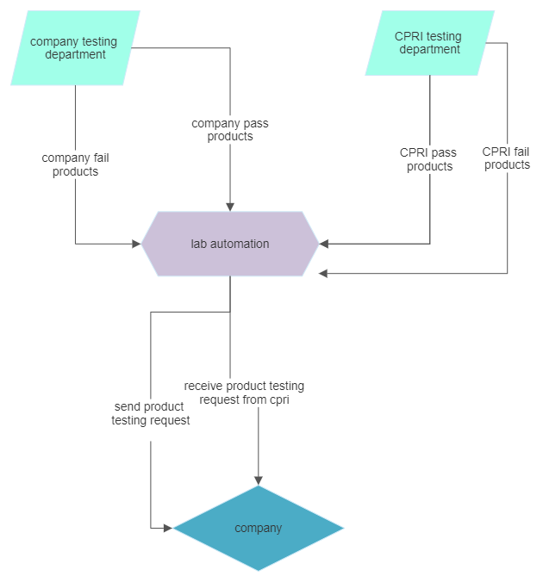

**ADMIN FLOWCHART**

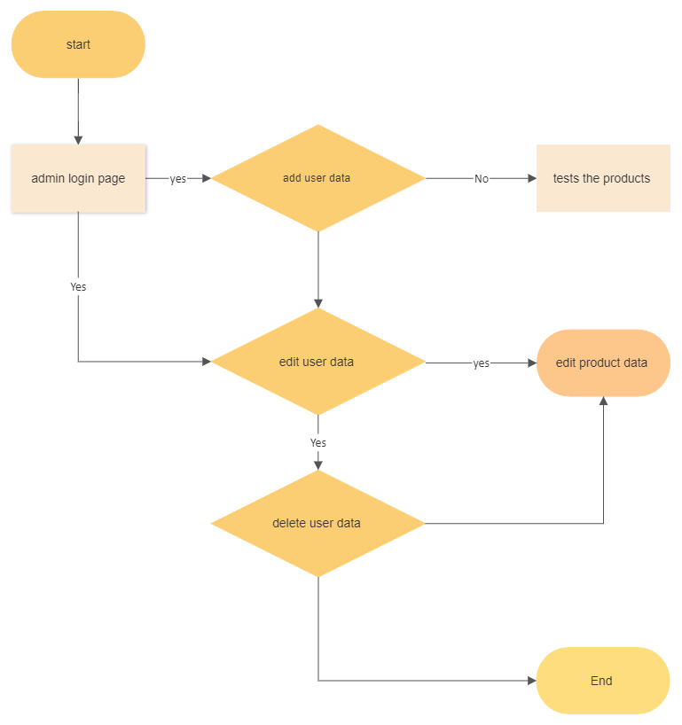

**LOGIN FLOWCHART**

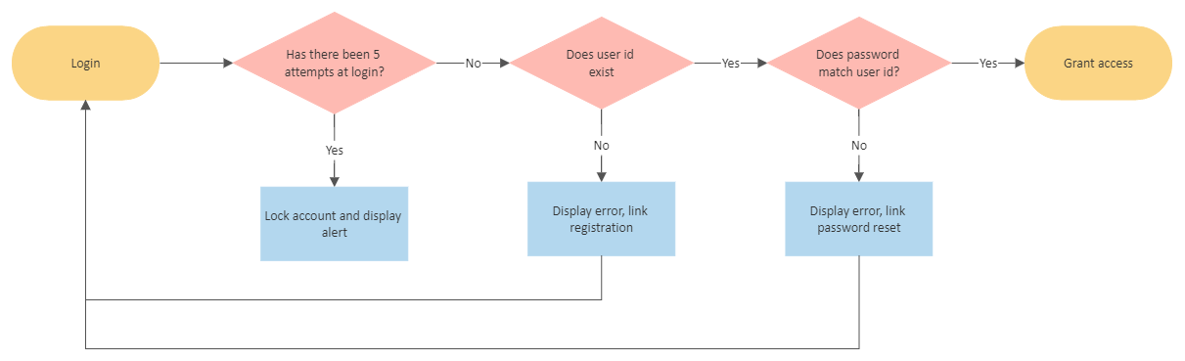

**PRODUCT FLOWCHART**

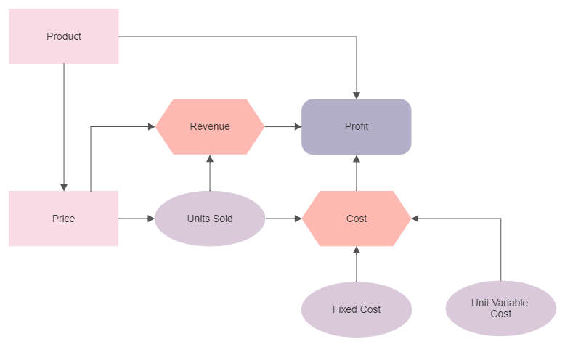

**USER FLOWCHART**

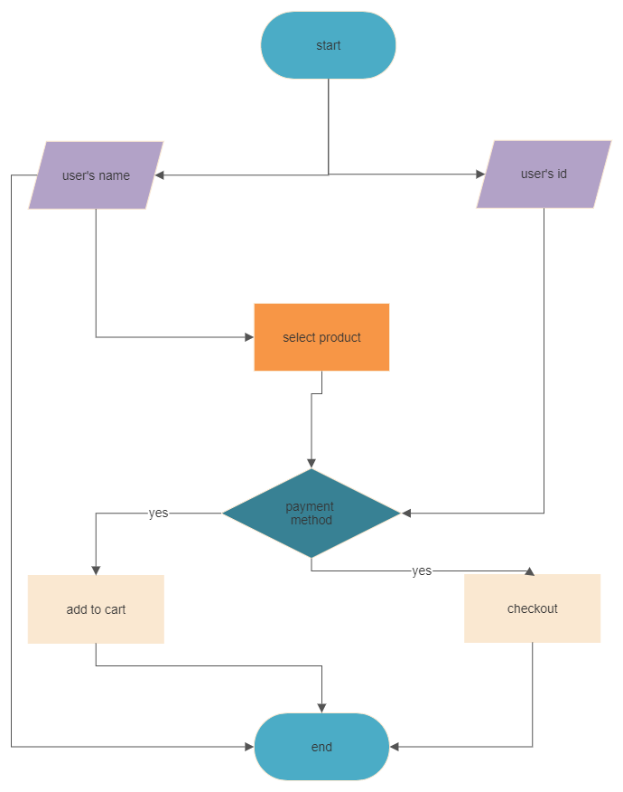

**SCREENSHOTS**

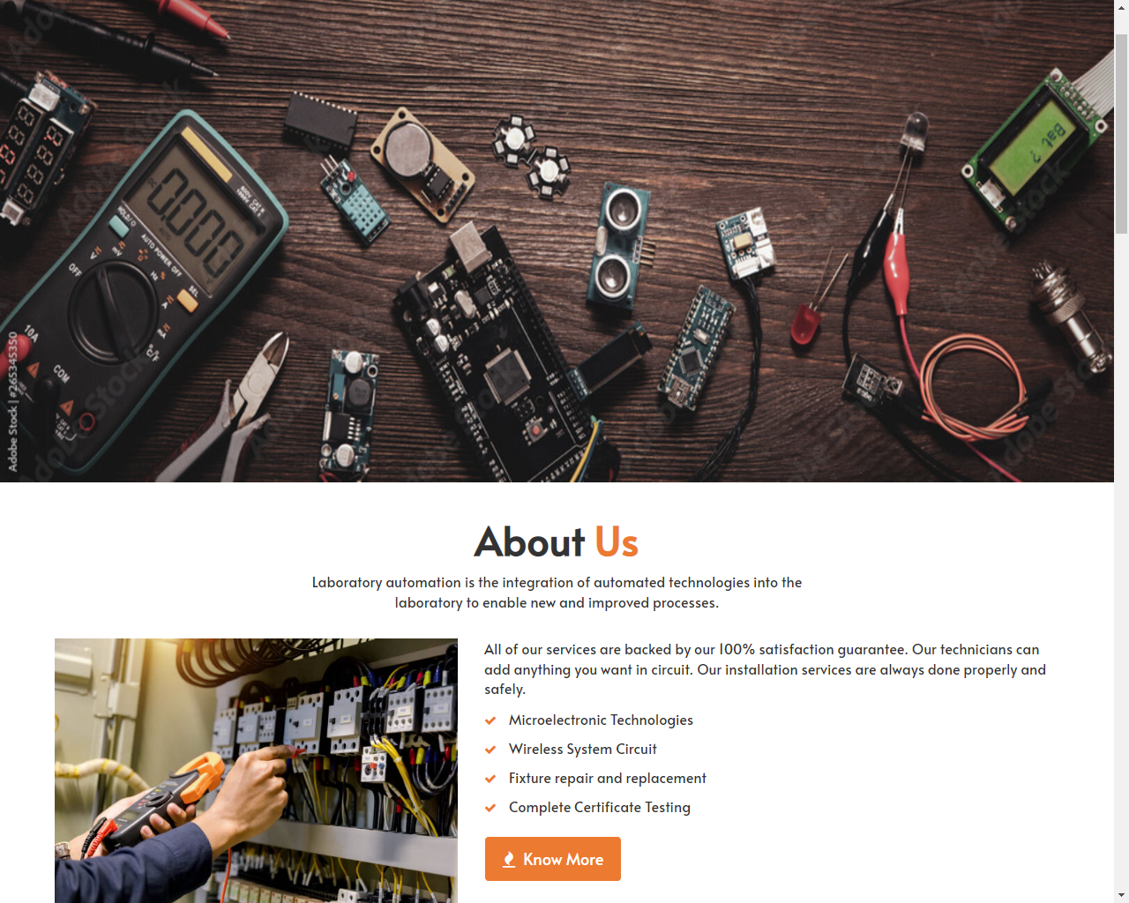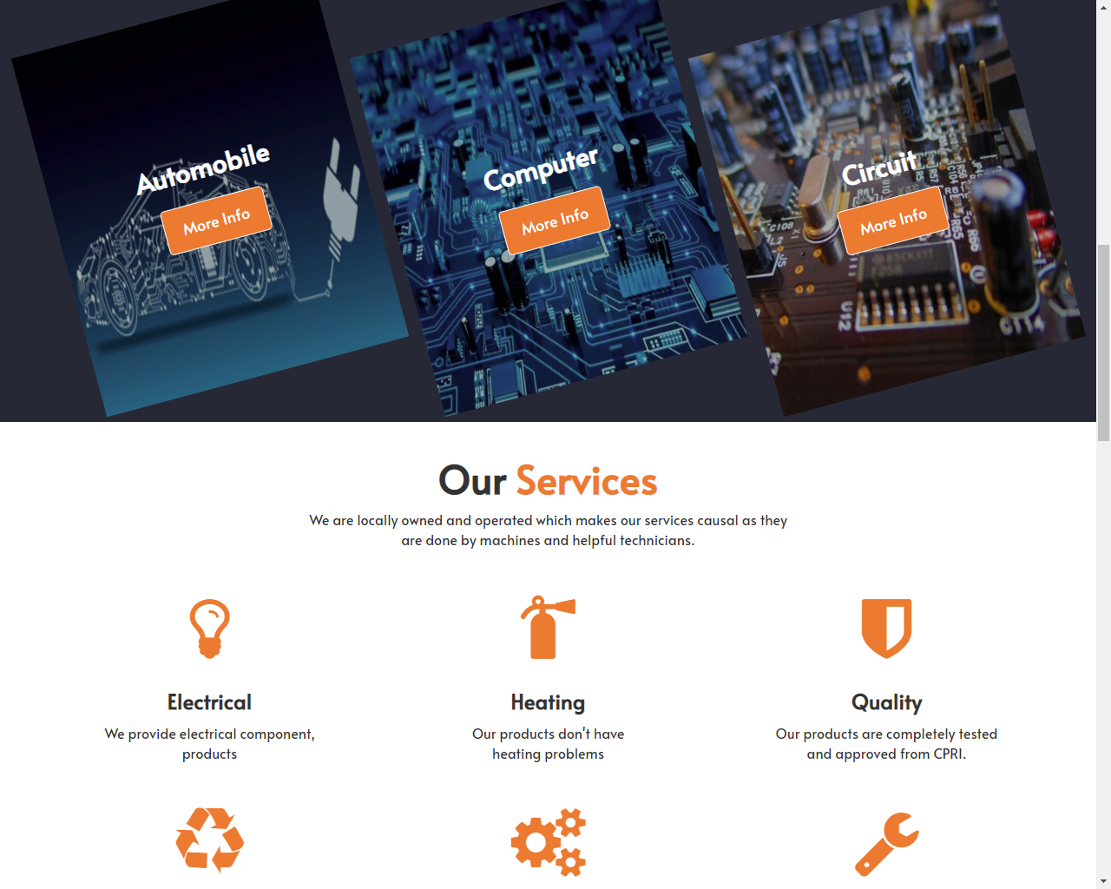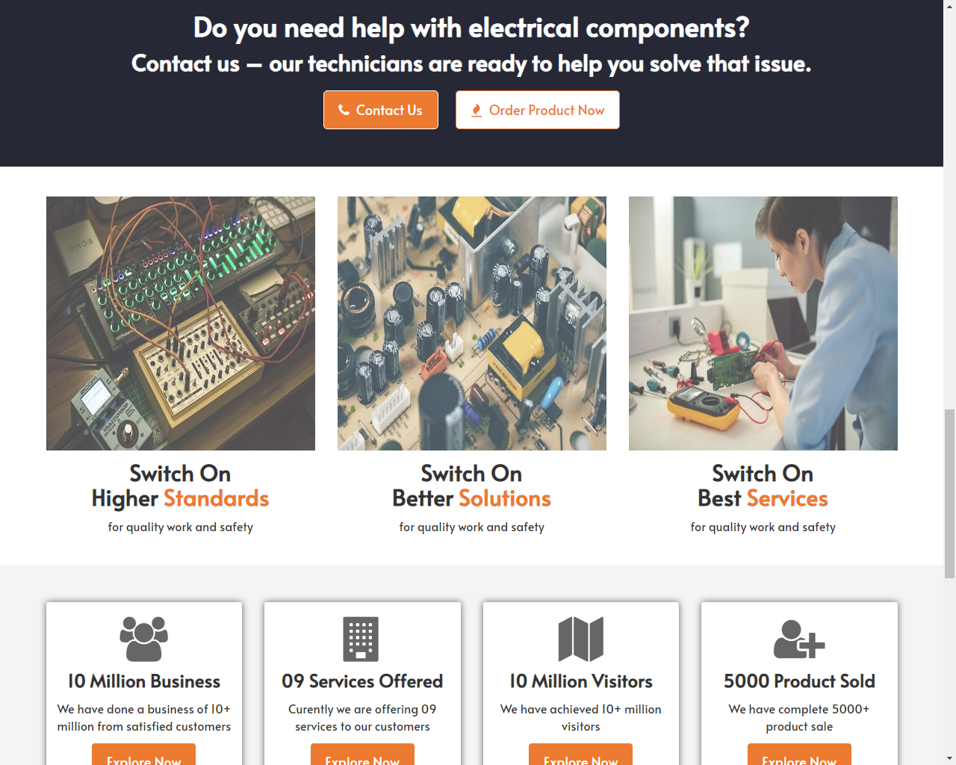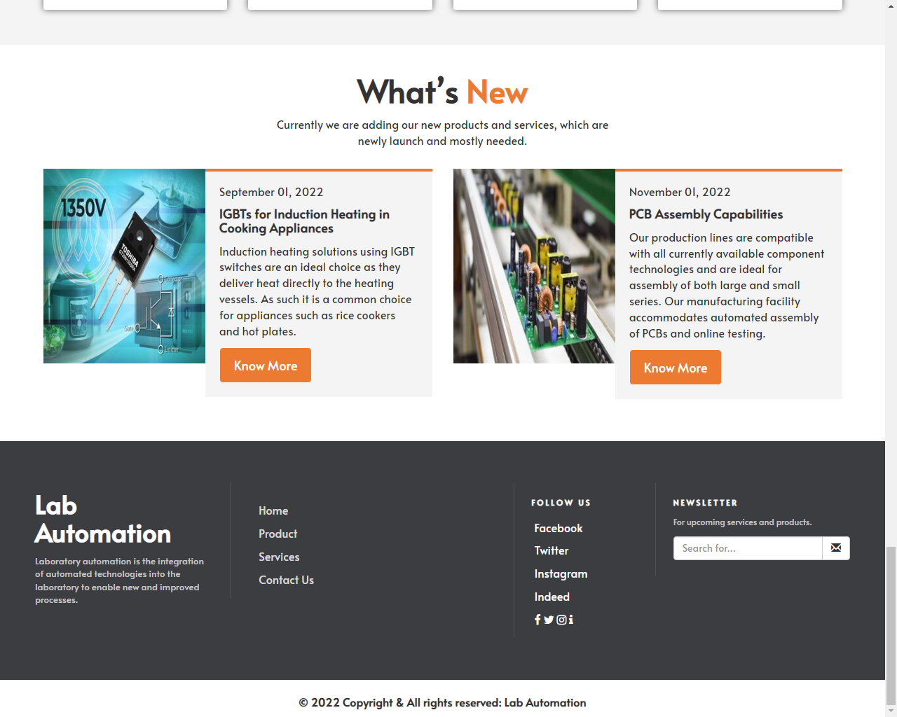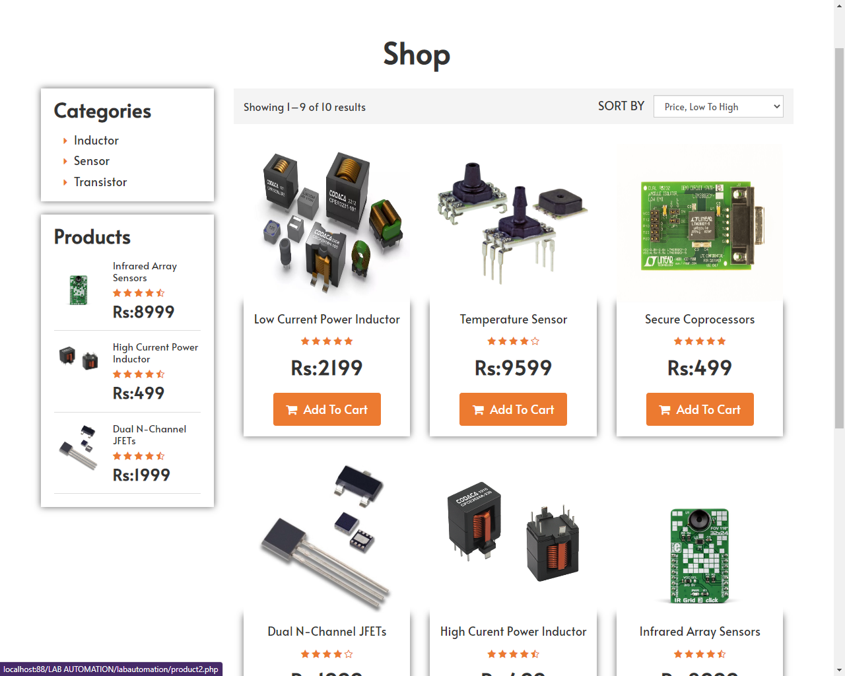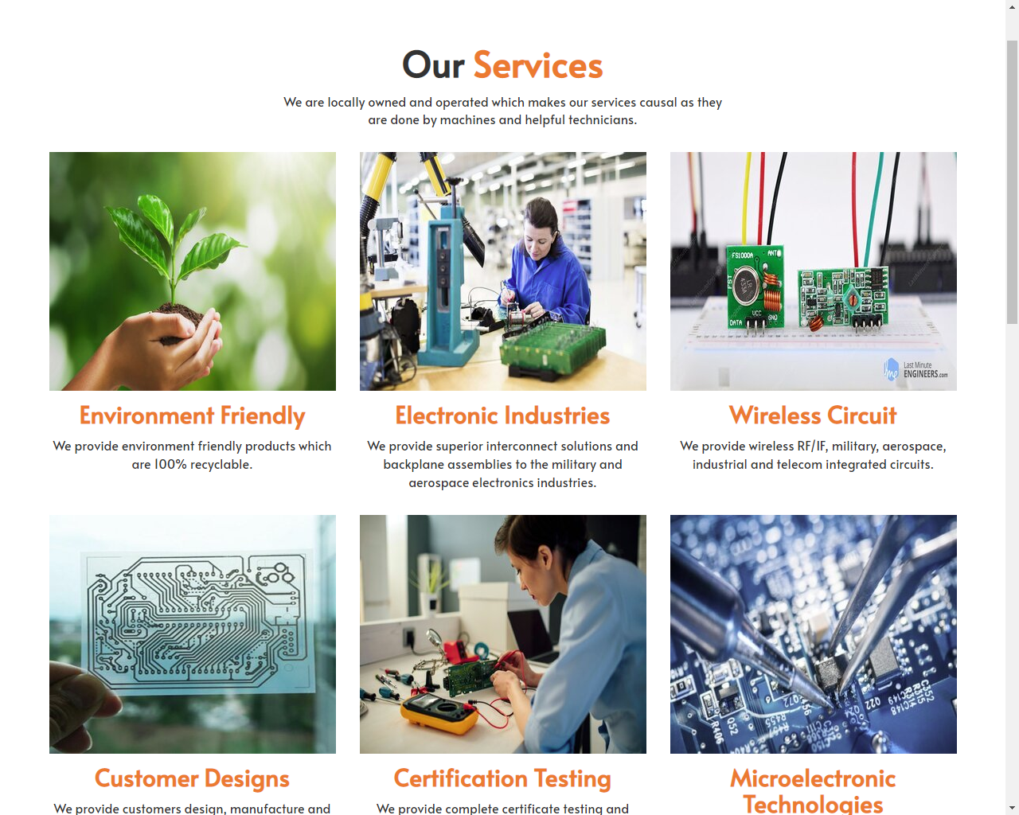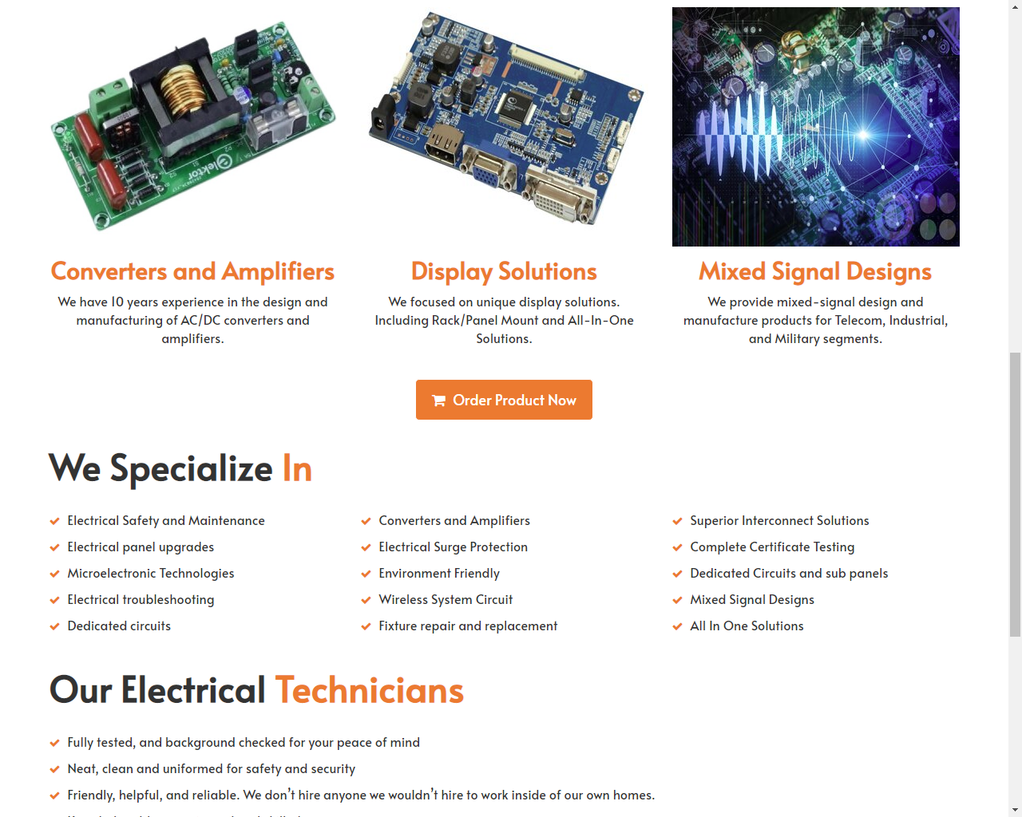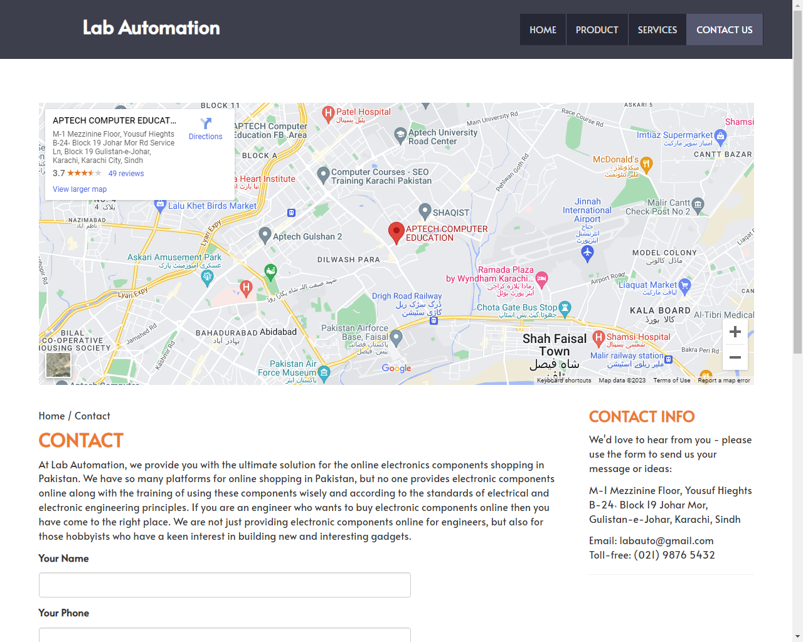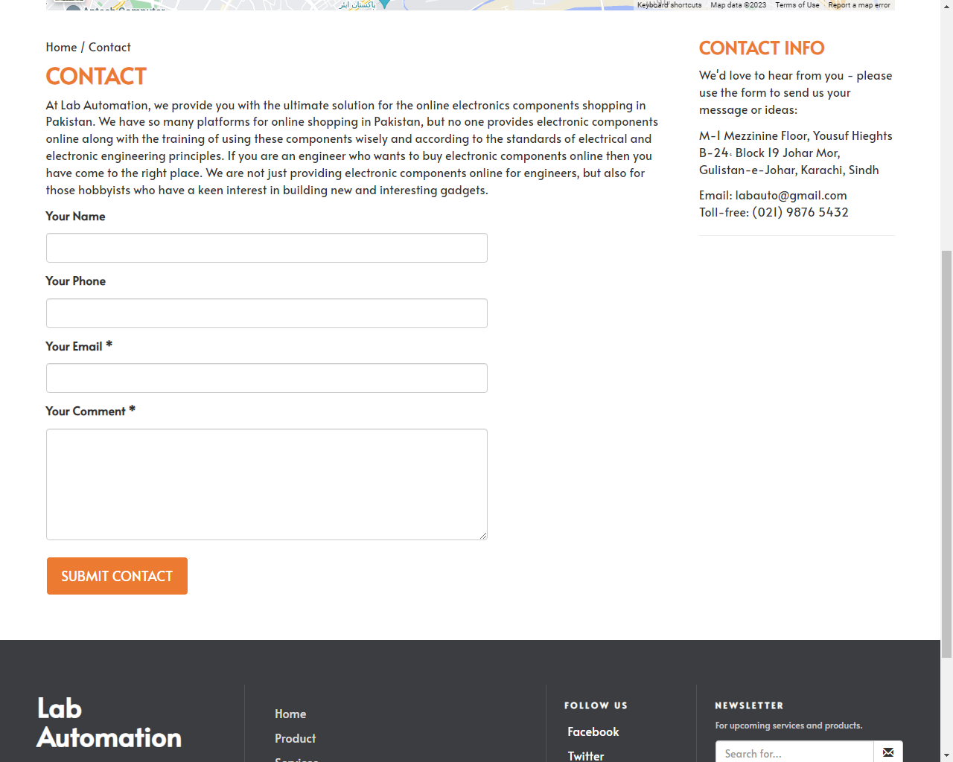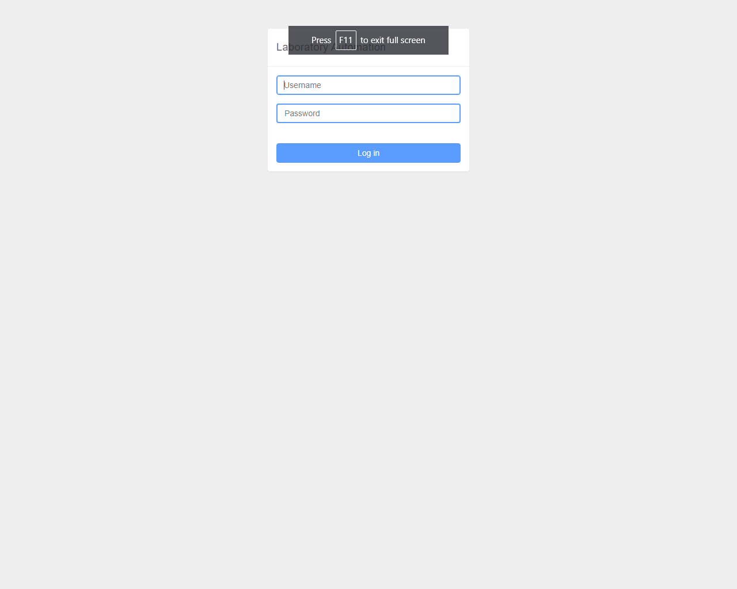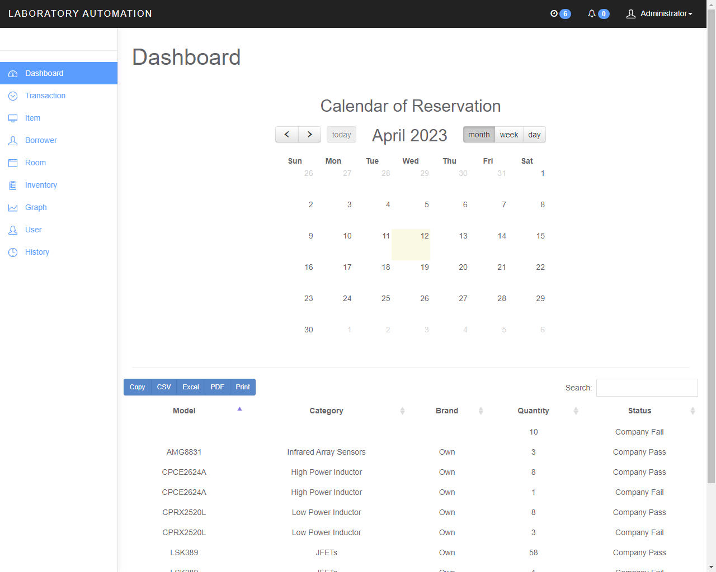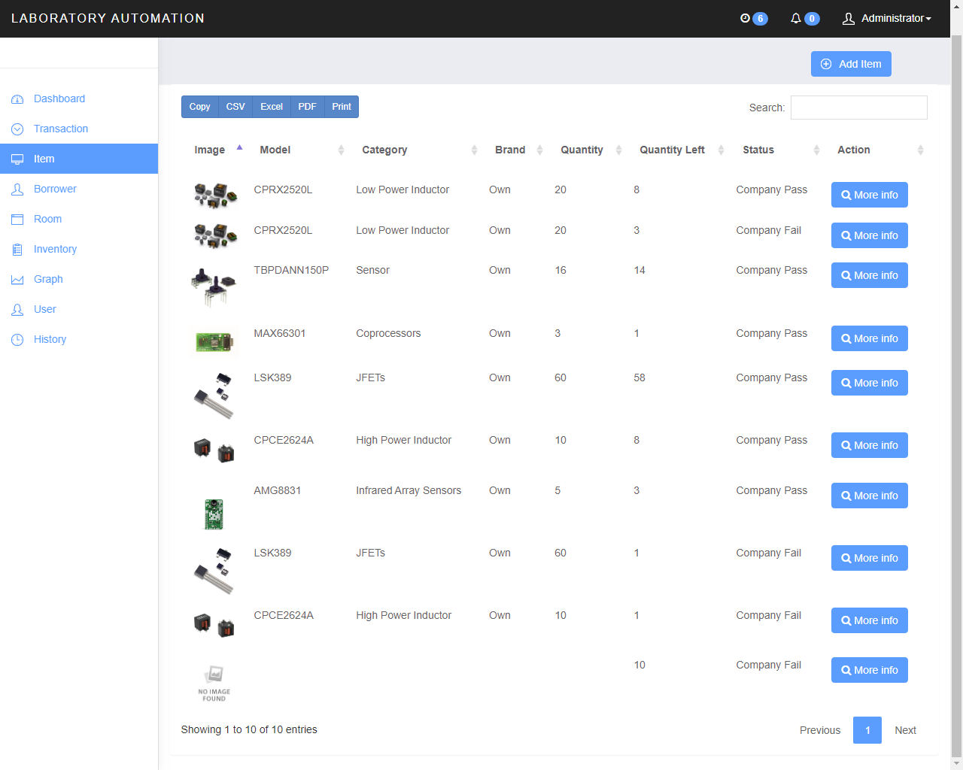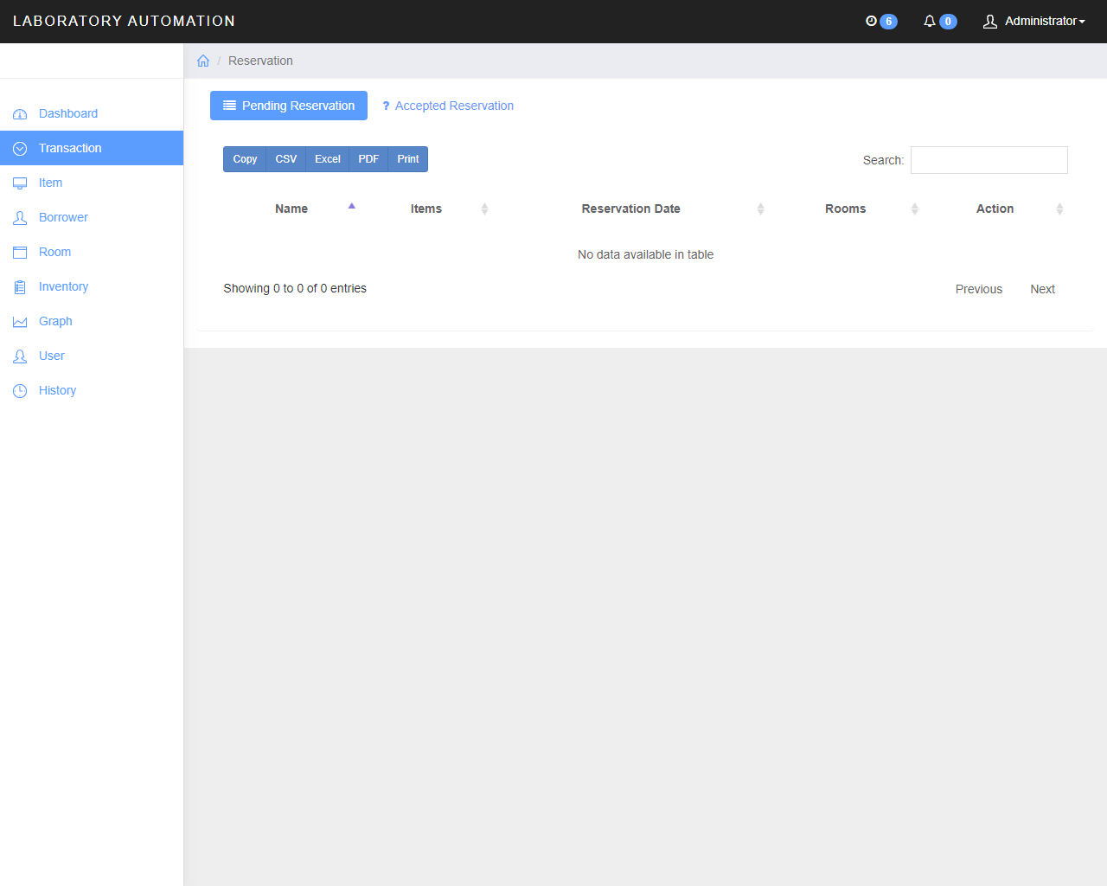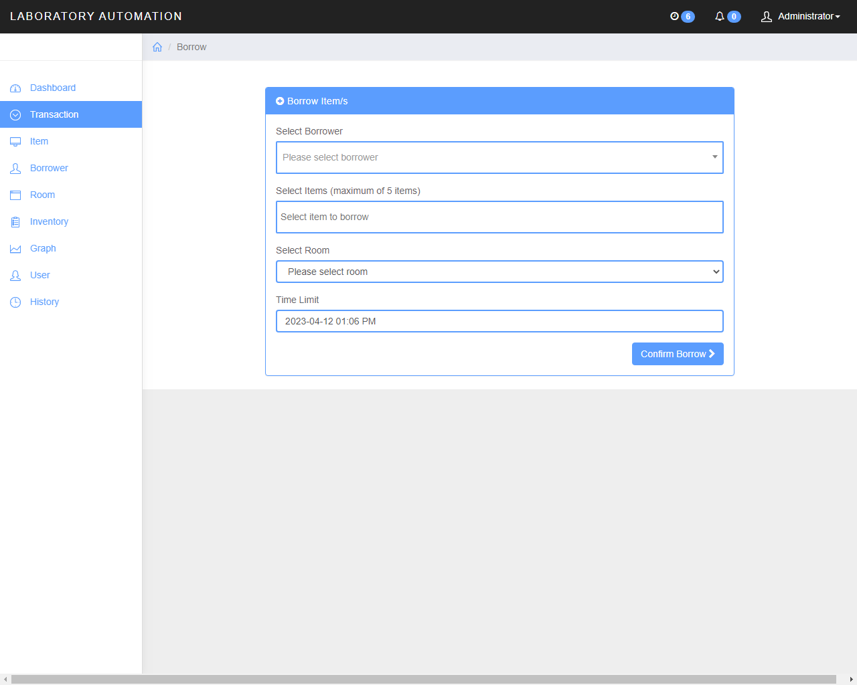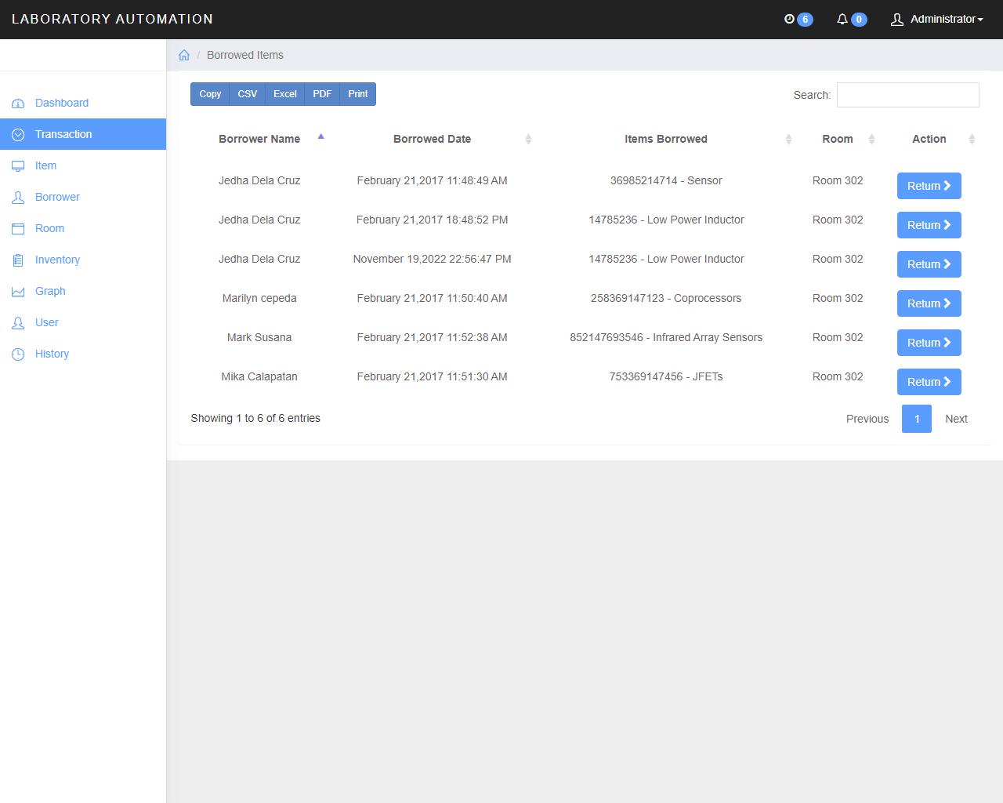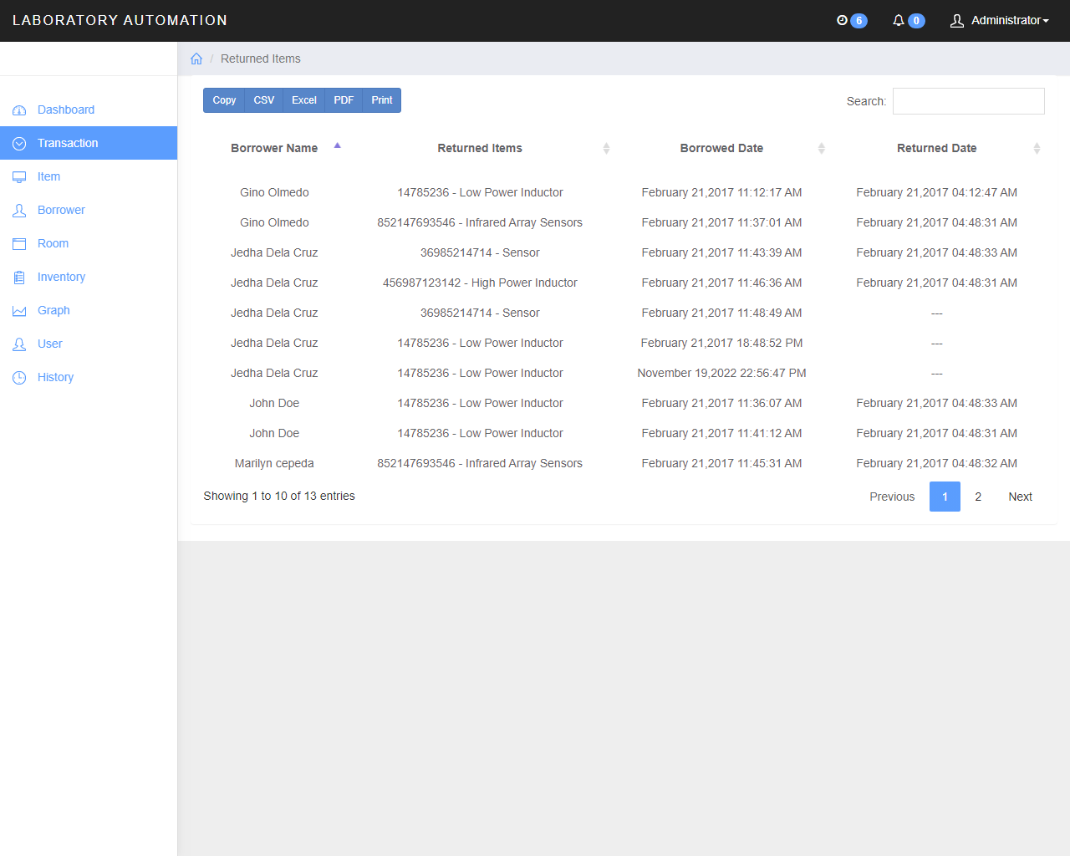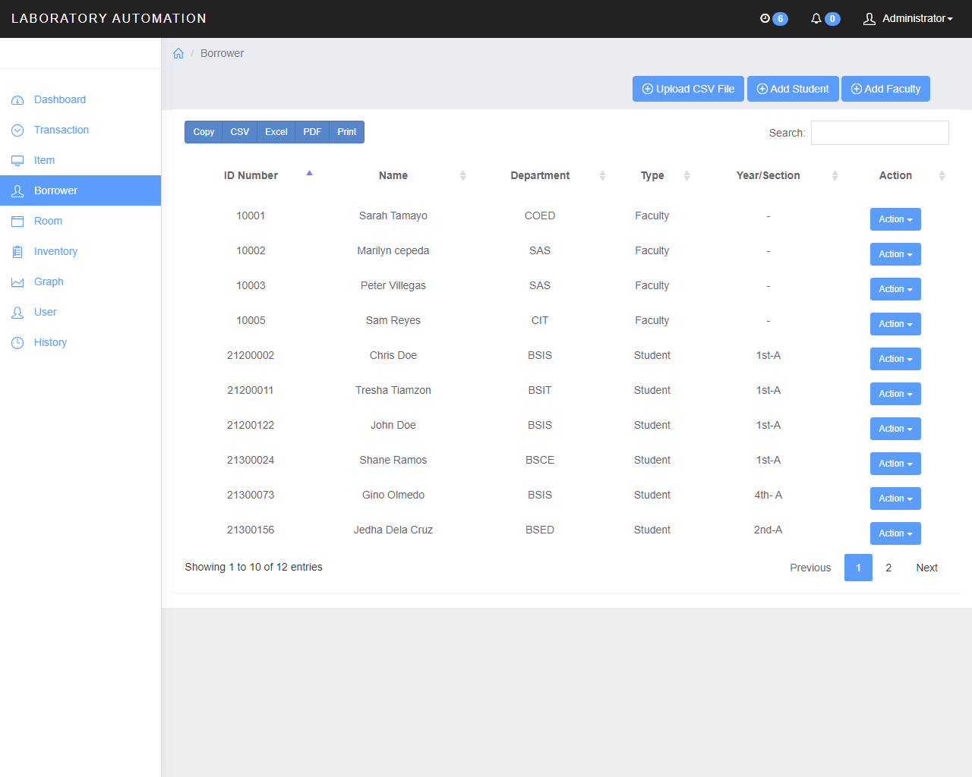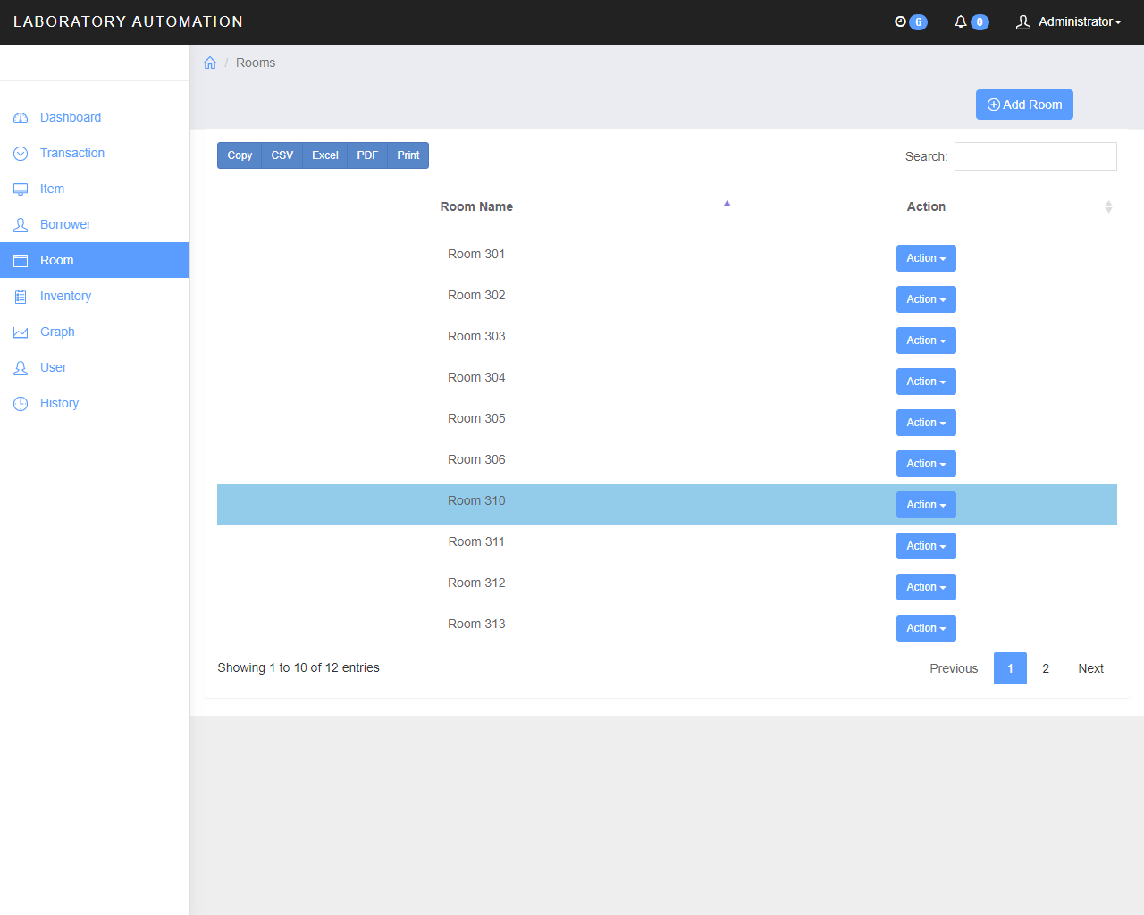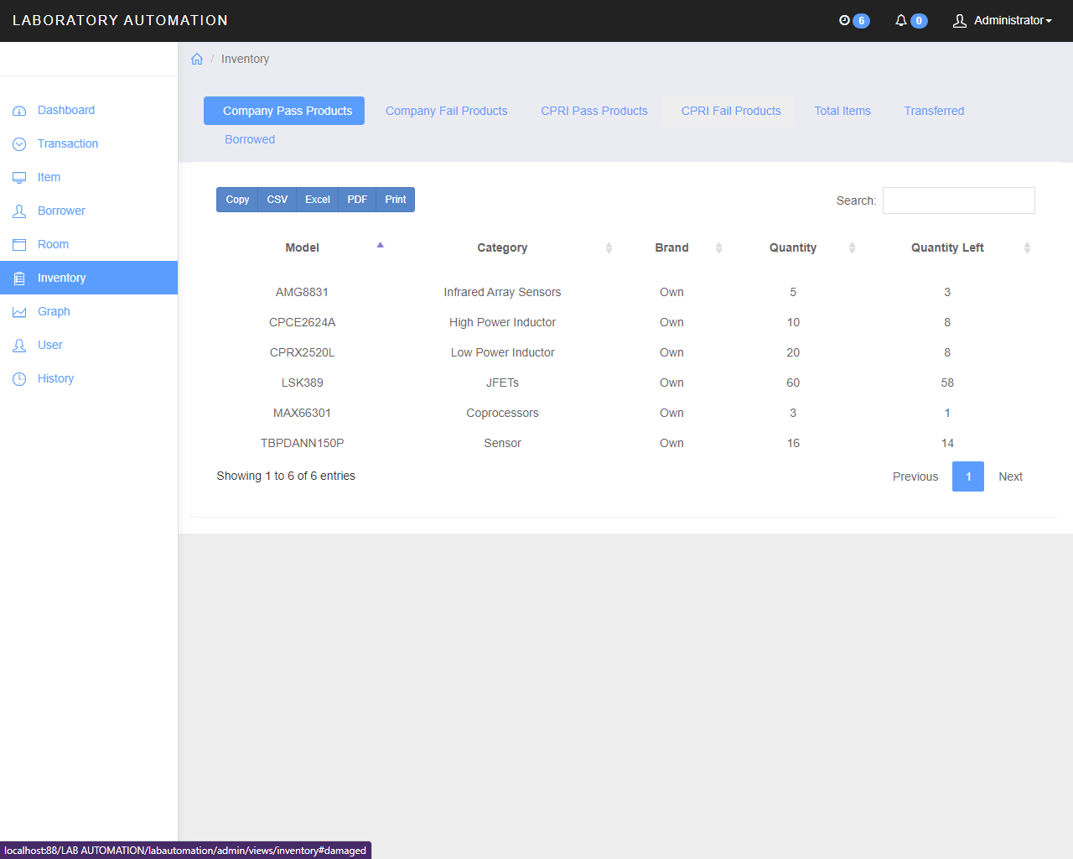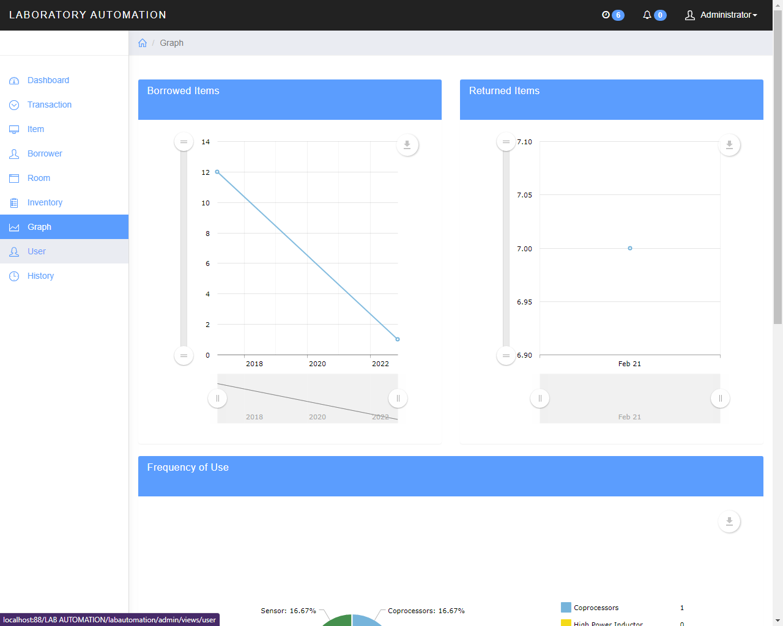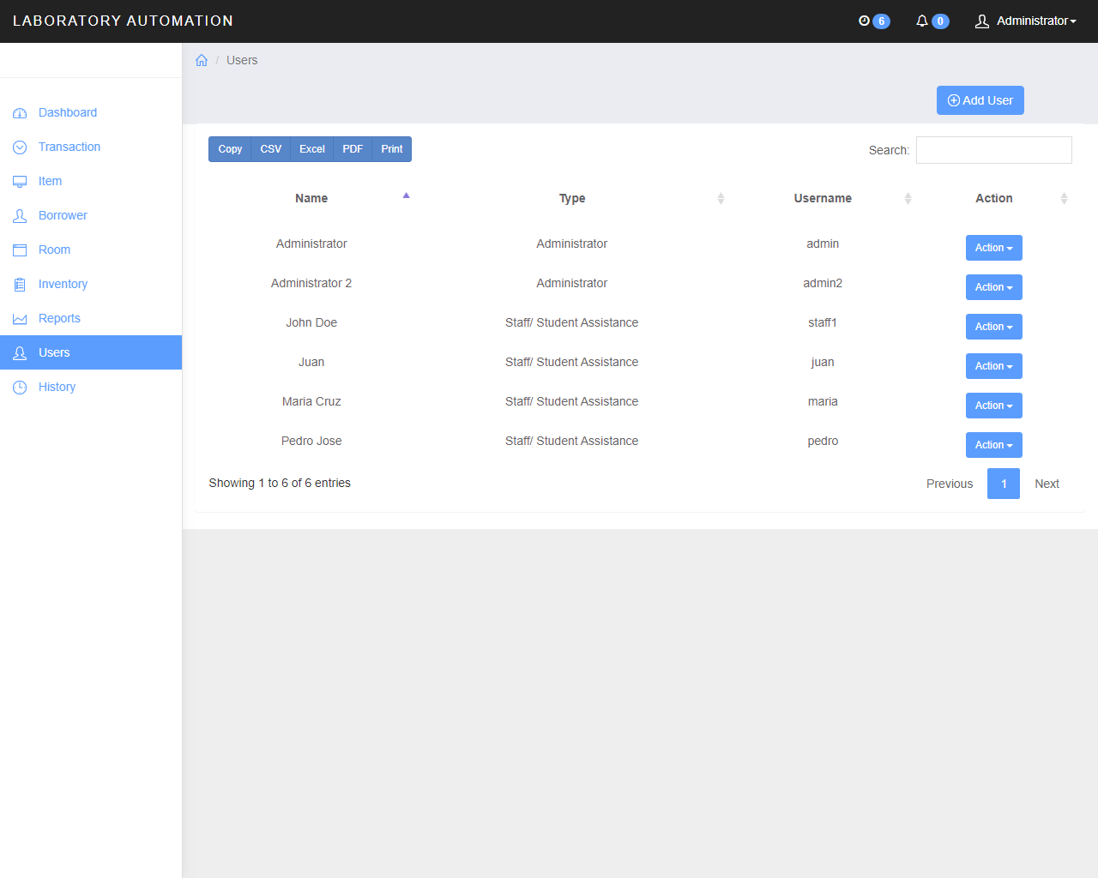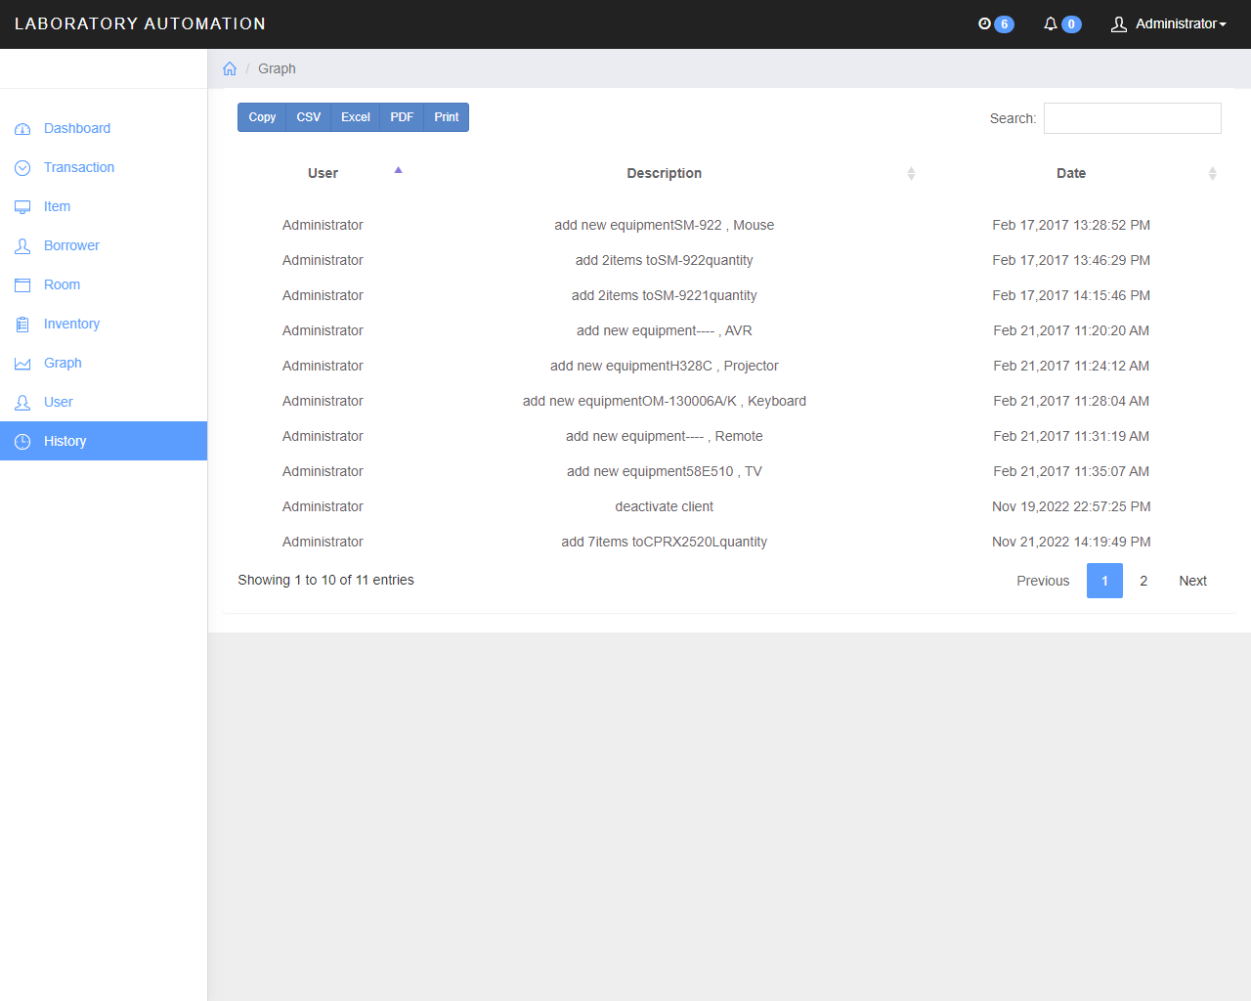

**SOURCE CODE**